Global Recycling Day (03/18):
For Greiner, the future lies in the circular economy

- Plastics and foam processor Greiner aims to be a fully circular business by 2030
- To this end, Greiner relies on its "Design For Recycling" strategy, new business models, and innovative partnerships
- With its own recycling plant, Greiner is able to secure access to secondary materials and comprehensive expertise

Vienna/Kremsmünster, March 14, 2024 – For plastics and foam company Greiner, the future lies in the circular economy. Greiner's vision in this area does not just include recycling but also developing re-usable products and generally conserving resources along the entire value chain.

"The circular economy is the opposite of a throw-away society. It does not see waste as garbage but as a valuable raw material. This is where our future lies. This is why circular business models are also a central pillar of the Group-wide corporate strategy that has been devised for the period up to 2028," explains Manfred Stanek, member of the Executive Board of Greiner AG.

A key theme here is "Design For Recycling," a guideline for product development. Products are designed and produced so that, ideally, they are 100% recyclable. This involves looking at how products have to be designed so that they can be collected, separated and, finally, recycled as easily as possible.

"We want to drastically reduce our emissions and be a fully circular business by 2030. The production of packaging made from r-PET generates significantly fewer CO₂ emissions than when new PET is used. So, the circular economy also offers enormous opportunities to achieve our climate targets," explained Stefan Grafenhorst, Vice President of People & Sustainability at Greiner AG and a member of the Austrian federal government's circular economy task force, which was set up last year.

Subsidiary Greiner Recycling produces its own r-PET flakes
Greiner is already working directly with recycling plants and other companies along the value chain to better close the loop. Greiner Packaging reached a milestone one and half years ago when it purchased the first recycling plant of its own in Serbia. The r-PET flakes produced there are reused in the manufacture of new food packaging, among other things. The entry into the recyclables business has helped Greiner place an even heavier focus on cycles.
For more on Greiner Recycling, see the interview with Peter Fessl, Director of Operations Recycling at Greiner Packaging.

In line with the Group-wide "Blue Plan" sustainability strategy, Greiner is not afraid to blaze its own trail and pursue completely new approaches. For example, Greiner Innoventures, Greiner's start-up hub, is constantly on the lookout for innovative ideas for circular business models. Strategic partnerships also play a major role for Greiner when it comes to the circular economy.

Many circular projects with partner companies
The NEVEON foam division, for example, is a founding member of the recently initiated Austrian Mattress Alliance, which is focusing on "circular mattresses." In addition, NEVEON launched a partner project with BASF back in 2021 to close the cycle for mattresses through chemical recycling. The project has succeeded in returning discarded mattresses to the materials cycle and producing new, high-quality mattresses from recycled materials.
In the state of Upper Austria, Greiner Packaging is collaborating with local farmers that produce milk for schools and two other companies (Starlinger viscotec and PET-MAN) in a joint project in which the school milk is packaged in cups made of r-PET. This cooperation model along the regional value chain has al-ready been awarded the TRIGOS sustainability prize.
Read more: Trigos 2021: award received for sustainable school milk project (greiner-gpi.com)

In addition, the idea of reuse is playing an increasingly important role in products. Here, Greiner Packaging is producing reusable drinking cups that can be used at concerts, for example, and then remain in the cycle thanks to a deposit system.
Read more: Reusable Drinking Cup (greiner-gpi.com)

Text & image:
Text document as well as images in high-resolution quality for download:
https://greinerpackaging.canto.de/b/Q0P97

The images are available for free publication in the context of editorial reporting.

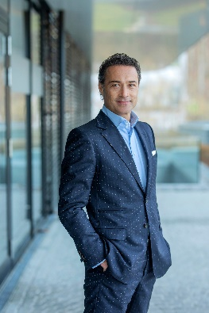  Caption: Manfred Stanek, Chief Operating Officer (COO) of Greiner AG.  Photo credit: Silvia Wittmann | 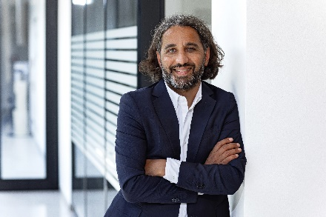  Caption: Stefan Grafenhorst, Vice President of People & Sustainability at Greiner AG.  Photo credit: Christian Huber
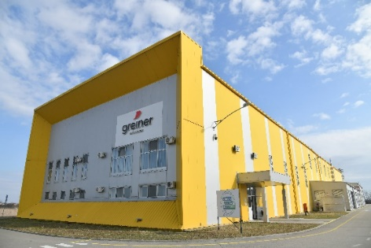  Caption: Greiner Recycling in Nova Gajdroba (Serbia).  Photo credit: Greiner Recycling | 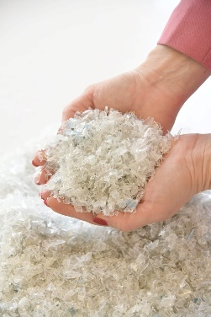  Caption: r-PET flakes.  Photo credit: Greiner Recycling

About Greiner
Based in Kremsmünster, Austria, Greiner is a world-leading plastics and foam solutions company. With the three operating divisions Greiner Packaging, NEVEON, and Greiner Bio-One, the company is at home in all manner of industrial sectors. Established in 1868, the Group is now one of the leading foam producers and plastics processors for the packaging, mattress, furniture and sports industries, for the mobility sector as well as for medical technology and the pharmaceutical sector. In fiscal 2022, Greiner generated turnover of EUR 2.33 billion and had over 11,600 employees at 120 locations in 34 countries. The Executive Board consists of CEO Saori Dubourg, CFO Hannes Moser and COO Manfred Stanek.
www.greiner.com

Greiner Media Contact:
Gerti Wallner
Media Spokesperson Greiner AG
Mobile: +43 664 8859 8617
E-mail: gerti.wallner@greiner.com

About Greiner Packaging
Greiner Packaging is one of the leading European manufacturers of plastic packaging in the food and non-food sector. For over 60 years, the company has stood for a high level of solution competence in development, design, production, and decoration. Greiner Packaging meets the challenges of the market with two business units: Packaging and Assistec. While the former stands for innovative packaging solutions, the latter focuses on the production of customized technical parts. Greiner Packaging employs over 5,000 people at 30 locations in 19 countries worldwide. In 2022, the company achieved an annual turnover of 909 million euros (incl. joint ventures). This is almost 40% of Greiner’s total turnover.
www.greiner-gpi.com

Greiner Packaging Media Contact:
Jörg Sabo
Greiner Packaging International GmbH
Gewerbestraße 15, 4642 Sattledt, Austria
Mobile: +43 664 3240595
E-mail: j.sabo@greiner-gpi.com

